Dynamic Traffic Light Control

Guide :Prof. P. M. Bagul.

Domain : Embedded Systems, IoT

Rohit Tondare

Rahulnarayan Iyer

Aditya Undre

Akanksha Patil

**ABSTRACT**

In recent era, due to the increase in population and the number of vehicles bought, there is a problem of congestion of traffic in the major cities around the globe. This not only increases the time delay but also increases the fuel consumption and air and noise pollution. It is observed that conventional traffic flow is intricate and non predictable. There is also a lack of synchronization between signals due to which additional traffic jams are created. Furthermore emergency vehicles like ambulances, fire trucks etc. are delayed. This project aims to solve the aforementioned problems by implementing real time control of the traffic signals using Image Processing, IoT and Object detection. Embedded Systems are small and can be integrated with the existing infrastructure in order to reduce the cost and complexity. We have proposed the use of Image Processing and Object Detection to calculate the density of traffic and also to identify Emergency vehicles, and IoT in order to attain synchronization between signals.

**CHAPTER I**

**INTRODUCTION**

* 1. **Introduction to Dynamic Traffic Light Control.**

Automobile is a great invention for people to travel and extend their reach. Unfortunately, in recent times the increasing number of vehicles can cause a series of economical and social problems. However due to limited availability of land, the roads cannot be widened to suit the traffic needs.  Conventional traffic light systems use a fixed cycle of predefined pattern to control the dynamically changing traffic flow. There are numerous conventional methods for traffic signal control but most of them sometimes fail to deal efficiently with the complex, time-varying traffic conditions and controller can’t satisfy real-time character for traffic signal. The existing methods for traffic signal control can be classified into two categories: Fixed-Time strategies and Traffic-Responsive strategies. Fixed-Time strategies use historical traffic information to decide traffic signal settings, while Traffic-Responsive strategies make use of real-time measurements to calculate in real time the suitable signal settings. Dynamic Traffic Light Control refers to the control of flow of traffic via the signals in real time i.e. Traffic Responsive strategy.

* 1. **Need of Dynamic Traffic Light Control.**

It commonly occurs that, at a particular intersection there is high density of traffic in one lane and there is very low density of traffic in the others. Despite that, the green time for all the lanes is the same. Another major problem is the excess waiting time for emergency vehicles. Due to the static nature of current system, there is no easy way to detect emergency vehicles. As there is no synchronization between signals, there is no free flow of traffic which increases the overall waiting time. Due to this Emergency vehicles are stuck in traffic and can be fatal for patients.

* 1. **Advantages of Dynamic Traffic Light Control.**

Dynamic Traffic Light Control will provide synchronization between signals, ensure priority to Emergency vehicles and drastically reduce the waiting time while taking full advantage of the existing infrastructure. Giving priority to Emergency vehicles will help save lives. Sy-----nchronization between signals will ensure that the Emergency vehicle is getting a free lane as well as ensure free flow of traffic. Calculation the density of traffic will help reduce the overall waiting time at a signal.

* 1. **Introduction to IoT.**

The term “Internet of Things” was coined by Kevin Ashton in 1999. The ‘Thing’ in IoT can be any device with any kind of built-in-sensors with the ability to collect and transfer data over a network without manual intervention. The embedded technology in the object helps them to interact with internal states and the external environment, which in turn helps in decisions making process. In a nutshell, IoT is a concept that connects all the devices to the internet and let them communicate with each other over the internet. IoT is a giant network of connected devices – all of which gather and share data about how they are used and the environments in which they are operated.

**1.4.1 Hardware used for IoT.**

In order to connect the devices to the internet, a Wi-Fi module is used. In our project we are using an ESP8266 derived module called NodeMCU. ESP8266 is a Wi-Fi microchip which was developed by Espressif Systems that comes with both TCP/IP and a microcontroller. NodeMCU supports the MQTT protocol using Lua access the MQTT broker and can also drive various LCD’s, Relays, etc.

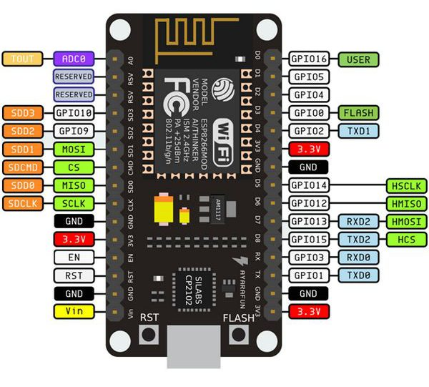

Figure NodeMCU

* 1. **Introduction to Image Recognition** **and Object Detection.**

Image Recognition or Object Detection refers to the process of identifying all the objects present is a particular image. An image recognition algorithm takes an image as input and outputs what the image contains. In other words, the output is a class label ( e.g. “cat”, “dog”, “table” etc. ). In order to recognize the objects in the image, the algorithm has to be trained to learn the differences between different classes. In order to make the job easier of the Image Recognition algorithm a few pre-processing steps are performed. Basically the pre-processing is used to normalize the brightness and contrast of the images. Sometimes even Gamma correction also produces slightly better results.

* + 1. **Hardware used for Image Recognition and Object Detection.**

The Raspberry Pi is a small credit-card sized computer developed in the United Kingdom by the Raspberry Pi Foundation. CPU speed ranges from 700 MHz to 1.2 GHz for the Pi 3 & has 1 GB of RAM. SD cards are used to store the operating system and program memory. It has four USB slots, HDMI and composite video output, and a 3.5 mm phone jack for audio. For lower level output it has a number of GPIO pins which support common protocols like I²C. Pi 3 is also equipped with Wi-Fi 802.11n and Bluetooth. There is a list of operating systems supported by Raspberry Pi like RISC OS Pi, FreeBSD, NetBSD, Plan 9 from Bell Labs, Windows 10 IoT Core, xv6, Haiku, HelenOS, Genode OS Framework and many more. The Raspberry Pi Foundation recommends the use of Raspbian, a Debian-based Linux operating system.

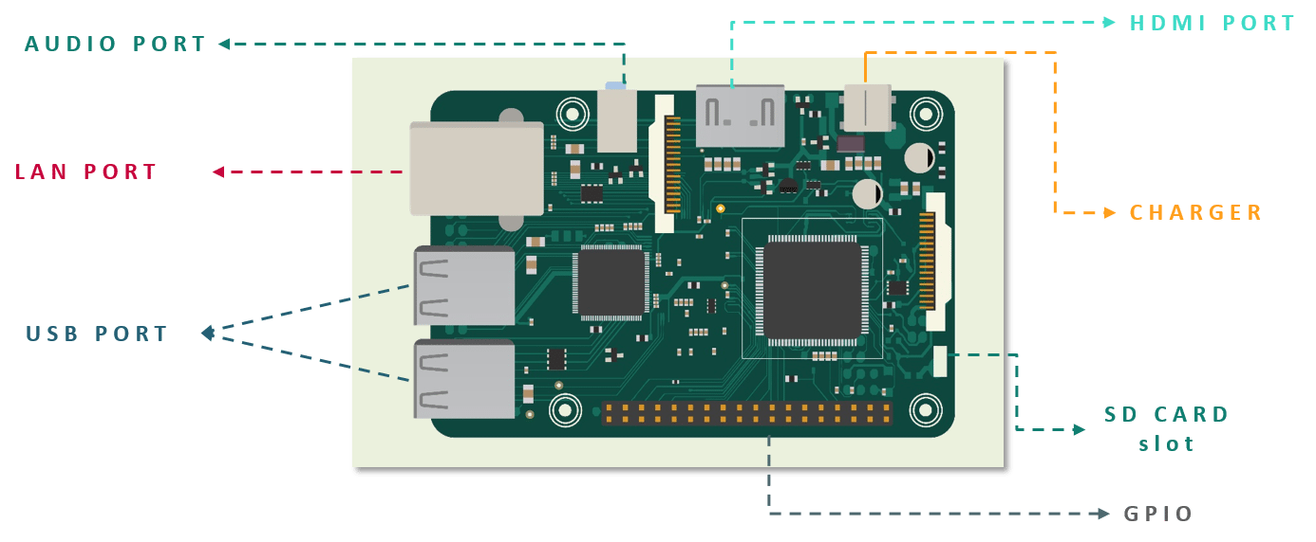

Figure 2 Raspberry Pi

* 1. **Survey.**

In our personal interview with the DCP of Traffic, Pune, he mentioned that currently there is a huge lack in infrastructure in our city. The road and signal infrastructure is not able to cope up with the rapid growth in the number of cars. The number of vehicles is increasing but the width of the roads is stagnant. As there are a lot of malls and buildings, increasing the width of the roads is not possible. Therefore a system is needed that will that will allow the movement of these vehicles in an organized manner. A similar technology is being used at 50 intersections in Pittsburgh and since launching, it has reduced wait times at intersections by up to 40%, according to the company. It also claims that journey times in the city have fallen by 25% while vehicle emissions have dropped by up to 20%. In Hagen, Germany, they are using artificial intelligence to optimize traffic light control and reduce the waiting time at an intersection. Simulations suggest it can decrease waiting times at lights by up to 47% compared to a traditional pre-timed signal plan. The system is already predicting traffic conditions 15 minutes in advance with 89% accuracy compared to what happens in reality.

**CHAPTER II**

**PROPOSED WORK**

* 1. **Motivation.**

It commonly occurs that, at a particular intersection there is high density of traffic in one lane and there is very low density of traffic in the others. Despite that, the green time for all the lanes is the same. Another major problem is the excess waiting time for emergency vehicles. Due to the static nature of current system, there is no easy way to detect emergency vehicles. Therefore we are inclined to design a system that will detect the lane with highest traffic and make its signal green. In case an emergency vehicle is detected that particular lane will be given highest priority until the emergency vehicle has passed.

* 1. **Methodology.**

In order to reduce the waiting time at a signal, we are proposing the use of Dynamic Traffic Light control with the help of Image Recognition, IoT and Object detection. The major data will be collected from the existing CCTV cameras. With the help of the data from the CCTV cameras, Emergency vehicles also will be detected. With the help of this system, there will be no waiting time for Emergency vehicles. There will be intercommunication between signals at adjacent intersections as well as between the signals at an intersection in order to have a full interconnection and synchronization in the system. This data will be backed up by data from maps provided by TomTom Maps API. TomTom maps has an API called Traffic API which will provide the data required for the backing the data from the CCTV cameras.

* 1. **Block Diagram.**

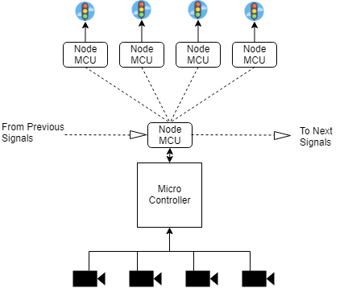

**CHAPTER III**

**THEORY AND CONCEPTS**

* 1. **Object Detection.**

The major data to the system is provided by the CCTV cameras. Object Detection is used in order to determine the density of traffic. A number of different AI object detection models are available viz. SSD, YOLO, Mobile-Net, etc. After comparing the different models, the SSD model was selected as it has good performance to accuracy ratio and can be computed on embedded devices like the Raspberry Pi.

Chart 1

Frames Per Second (FPS) is the number of frames a particular model can compute with per second. Chart 1 shows the comparison between different Object detection models based on the FPS. It can be concluded that YOLO has the highest FPS and SSD high model has the second best FPS.

Chart 2

The accuracy of a AI object detection and recognition model is defined as the number of objects detected and recognized accurately. Chart 2 shows the comparison between different AI models based on their accuracy. It can be concluded that SSD (high) has the highest accuracy while YOLO has low accuracy.

Chart 3

Chart 3 shows the comparison between different AI models based on FPS v/s Accuracy. SSD (high) has the best ratio while YOLO has lowest ration of FPS v/s Accuracy. In accordance with the observations based on Chart 3, SSD (high) AI model has been selected for object detection and recognition.

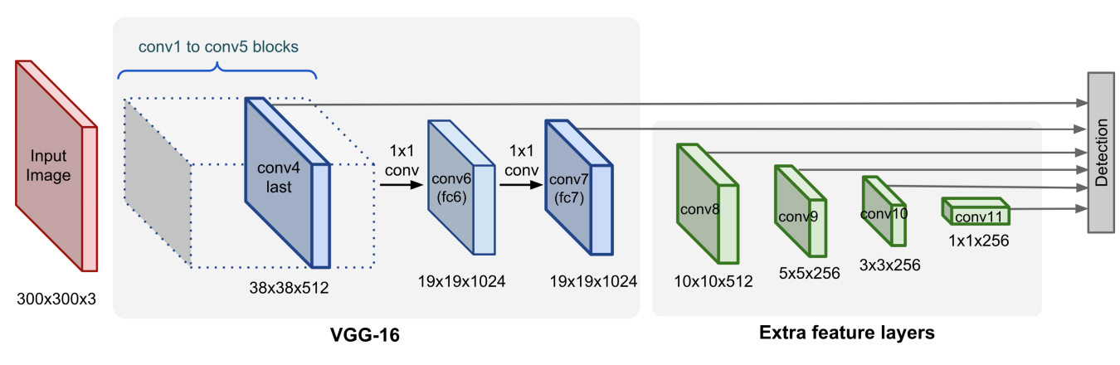

* 1. **Inter-Communication and Intra-Communication.**

The communication between signals at a particular road intersection is called Inter-communication while the transfer of data between signals at different road intersections is called Intra-communication. In order to achieve this, a database on Google Firebase is used. Firebase is a product developed by Google which is used to support the development of mobile and web applications. Google Firebase provides a number of services including: Cloud storage, ML kit, Performance Monitoring, Test Labs, Analytics and many more. For the communication between different nodes, each node will store data with a unique label based on the intersection. The storing and Reading of data will be done with the help of a NodeMCU. When the main controller has to read the data, it can directly access the data from the Web server.

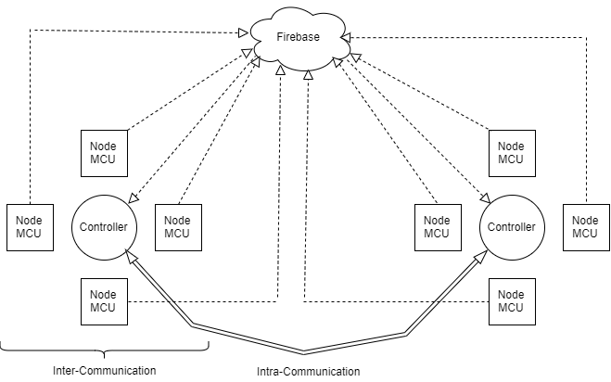

* 1. **TomTom Maps.**

In order to support the data recorded by the Object detection and Recognition AI model, live data from the maps is used. TomTom N.V is a multinational developer and creator of location technology and consumer electronics. TomTom provides a number of services for Navigation and also provide API for developers to develop various applications. The API’s offered by TomTom are Search API, Routing API, Maps API and Traffic API. For this application Traffic API is being used. The Traffic API is a suite of web services designed for developers to create web and mobile applications around real-time traffic. These web services can be used via RESTful APIs. The API results are in either of the two formats:

* **Traffic Incidents:** This provides an accurate view about traffic jams and incidents around a road network.
* **Traffic Flow:** This provides real time observed speeds and travel times for all key roads in a network.

The Traffic Flow offering is used to get real time data from the Traffic API. This data is also affected internally based on the historic data gathered by TomTom maps. The data provided by TomTom maps will come into the picture only when the traffic density is greater than the Field of View of the CCTV camera.

* 1. **Emergency Vehicles Recognition.**

In order to detect emergency vehicles present in the traffic, the SSD AI model is used. The model will detect the emergency vehicles like Ambulances, Police Vehicles, and Fire Trucks etc. After detection of an emergency vehicle, the system will inform the signal at the particular lane to let the traffic go by making the signal GREEN. To let the people at the other lane know an emergency vehicle is present, the RED light will be ON along with which the YELLOW light will BLINK with a particular frequency.

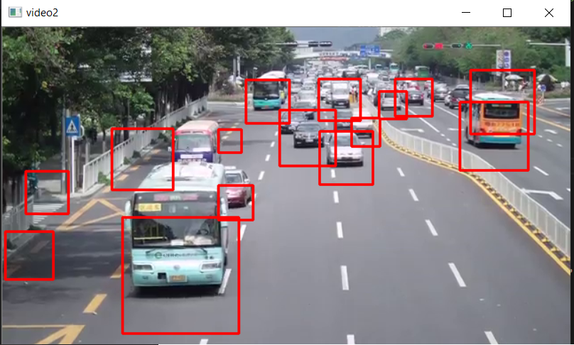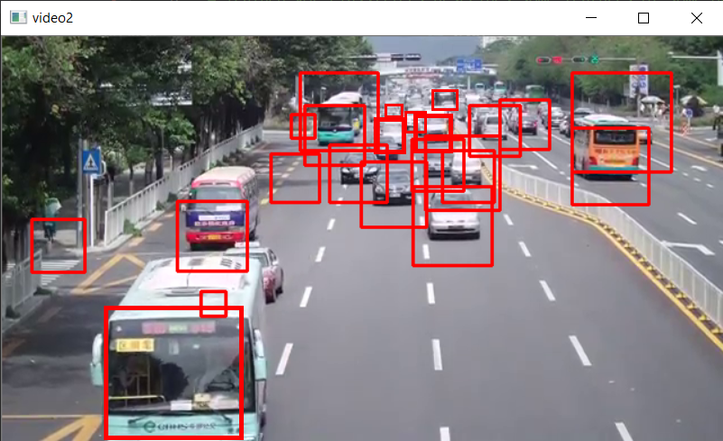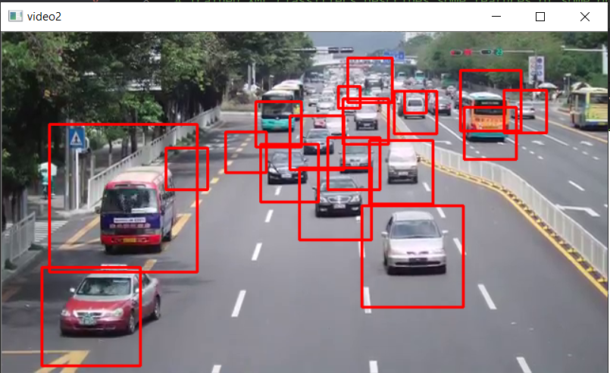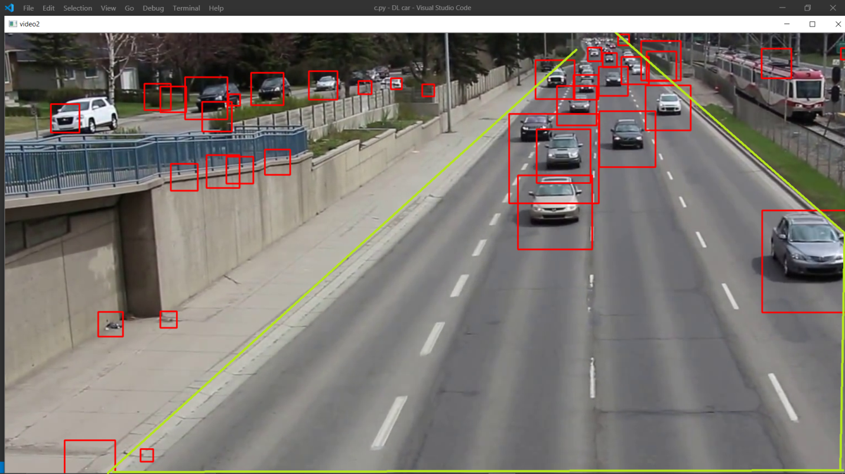

abstract

Intro

Need

Advantages

Intro to iot, ai etc

Survey

Proposed work

Block diagram

Flow Chart

Circuit diagram

Implementation

**Object detection**

**communication**

**Firebase**

**Main algo**

**Put images in results.**

**Images: Obj. detection, Firebase, TomTom maps.**

**Block diagram for obj. detection**

**Problem statement!!!**

**Block diagram**

**method**